Static Control Flow

1. **If everything is static in a class how does a control flow execute?**
   1. 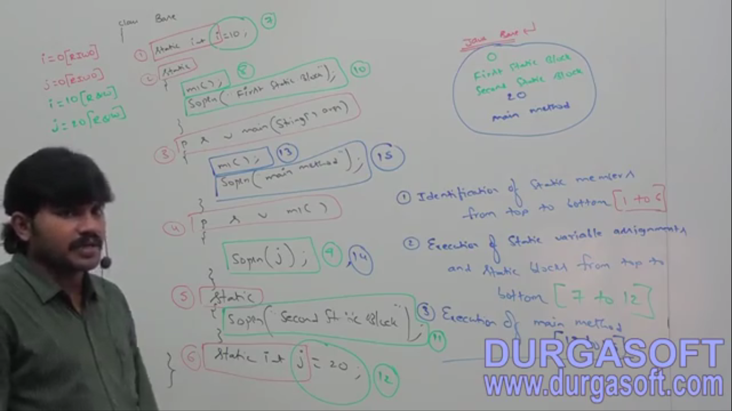

**During the 1st step, the identified static variables are assigned default value and those are in RIWO state**

1. **Direct Read and Indirect Read in Static Control Flow?**
   1. **Direct Read:**
      1. Inside static block, if we are trying to read a static variable, that read operation is called “Direct Read”
   2. **InDirect Read**:
      1. If we are calling a method from static block, and within that method, if we are trying to read a static variable, that read operation is called “**InDirect Read**”  
         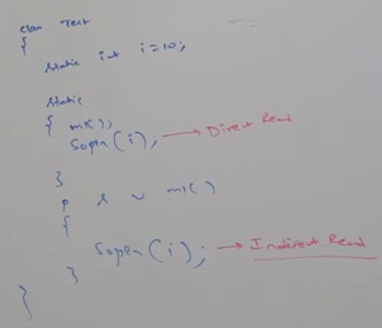

Indirectly Reading from static method the value of static variable

Directly Reading from static block the value of static variable

1. **RIWO**: If a static variable is just identified and the original value is just assigned then the variable is said to be in “RIWO” state 🡪 Read Indirectly & Write Only State  
   **NOTE**: If a variable is in RIWO state, then we can’t perform **direct read** but we can perform **indirect read**.   
   If we are trying to read directly then we will get compile time error saying 🡪 IllegaForwardReference  
   **NOTE:** Transition from RIWO to WR happens only via static variable initialization. If you set a value in static block, the variable is still in RIWO state.  
   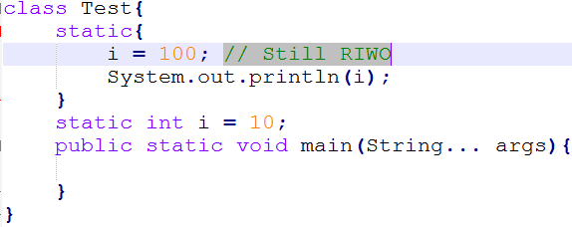
2. 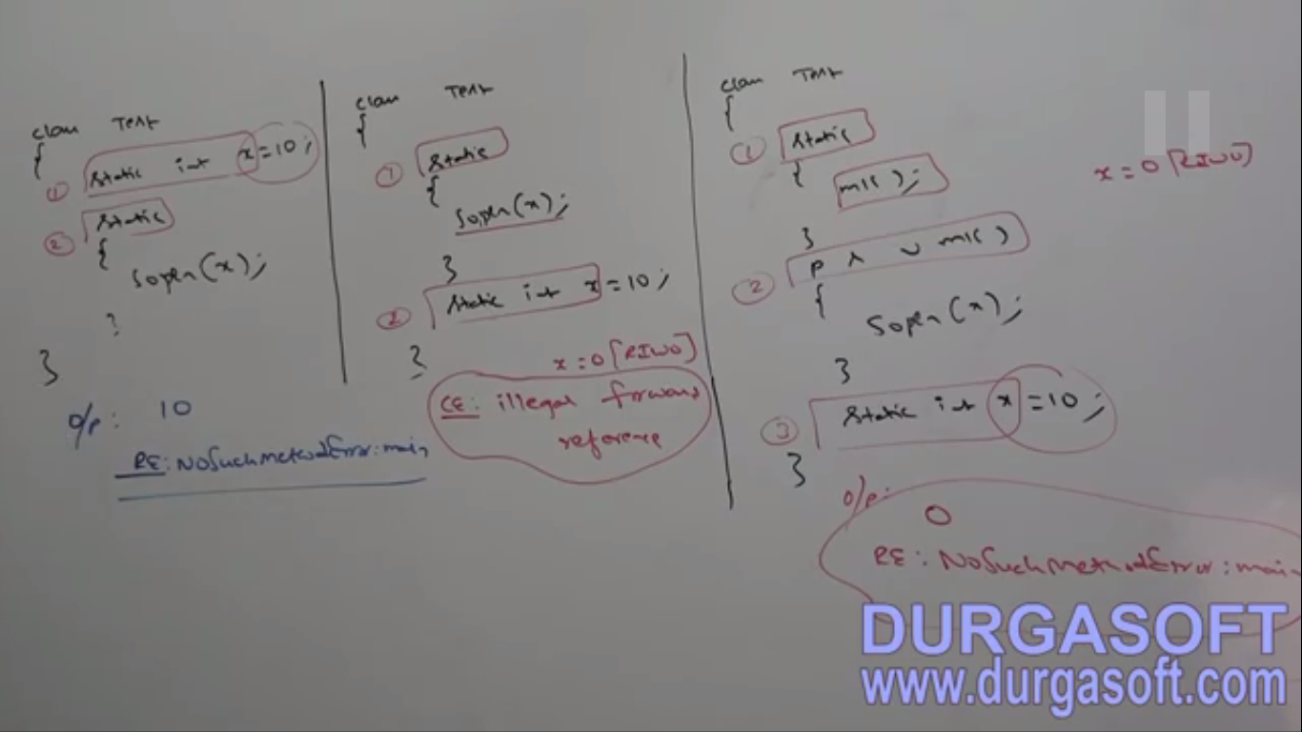
3. **d**